

SIMATS SCHOOL OF ENGINEERING
SAVEETHA INSTITUTE OF MEDICAL AND TECHNICAL SCIENCES
CHENNAI-602105

ASSESSMENT 1
CSA1006-SOFTWARE ENGINEERING

Problem 5: Ethical Evaluation of an AI Hiring System

Scenario

A company develops an AI hiring system to help select job applicants. During testing, the company finds that the AI gives lower scores to applicants from certain groups (such as gender, age, or ethnicity). This creates an unfair hiring process.

1.Ethical Issue Identification

Ethical Problems

- Bias and Discrimination
  - The AI treats some applicants unfairly because of their gender, age, race, or background.
- Lack of Fairness
  - Qualified candidates may not be selected even though they have the required skills.
- Lack of Transparency
  - Applicants do not know why they were accepted or rejected.
- Lack of Accountability
  - It is difficult to identify who is responsible when the AI makes a wrong decision.

Example

If two candidates have the same qualifications but the AI selects one only because of gender or age, the hiring process becomes unfair.

2. Actions Based on Data Ethics Principles

The company should follow these data ethics principles:
a) Fairness
- Remove bias from the training data.
- Test the AI regularly to ensure equal treatment for all applicants.
b) Transparency
- Clearly explain how the AI makes hiring decisions.
- Allow applicants to understand why they were selected or rejected.
c) Accountability
- Human recruiters should review important hiring decisions.
- The company should take responsibility for AI mistakes.
d) Privacy
- Collect only necessary applicant information.
- Protect personal data from unauthorized access.
e) Accuracy
- Train the AI using high-quality and balanced data.
- Continuously improve the model using updated datasets.

3. Potential Privacy Risks

Some privacy risks in an AI hiring system are:
- Personal information may be leaked.
- Unauthorized people may access applicant data.
- Sensitive information (age, gender, religion, etc.) may be misused.
- Applicant data may be stored without permission.
- Data may be shared with third parties without consent.
- Cyberattacks may expose confidential information.

4. Recommended Ethical Design Measures

To build a secure and ethical AI hiring system, the company should:
- Use balanced and unbiased training data.
- Allow human review before making final hiring decisions.
- Regularly check the AI for bias and fairness.
- Explain AI decisions in simple language.
- Follow privacy laws such as GDPR or local data protection regulations.
- Give applicants the option to correct or update their information.

BLOCK DIAGRAM
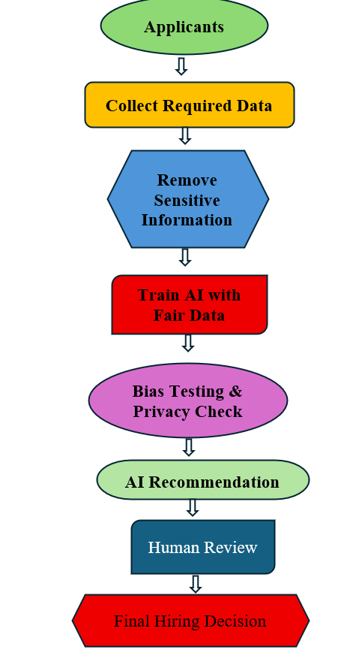

Real-World Example
A company uses AI to shortlist job applications. After testing, it notices that female candidates receive lower scores than male candidates with similar qualifications.
To solve this problem, the company:
- Removes biased training data.
- Retrains the AI using balanced data.
- Allows HR managers to review AI decisions.
- Explains why each candidate was selected or rejected.
This makes the hiring process fair, transparent, and ethical.

Conclusion

An AI hiring system should support fair and unbiased recruitment instead of creating discrimination. By following data ethics principles such as fairness, transparency, accountability, privacy, and accuracy, companies can build AI systems that are trustworthy, secure, and beneficial for both employers and applicants. Human oversight and regular bias testing are essential to ensure responsible AI decision-making.

